

**Trekking App**

**ABSTRACT**:

A smartphone app with a ton of features made specifically to meet the requirements of trekkers is the iOS trekking application. It provides many information and tools for organizing, monitoring, and navigating outdoor excursions and treks. maps are included. Users may design personalized routes using the route planning function, which also displays well-known trails and landmarks, and takes into account preferences like distance and level of difficulty.

Users of various skill levels may use the iOS trekking app since it is simple to use, intuitive, and adaptable. By giving them access to all the required equipment and materials in one location, it is a dependable companion for outdoor enthusiasts wishing to improve their trekking experiences.

**INTRODUCTION**:

The main purpose of developing a trekking application is to provide various features which may help many trekking enthusiasts out there. With the application users/trekkers can easily search for various trekking places around them, check the pictures of the place, total trekking trail and they can also check the trekking effort level. Users can also book for a guide and also they can share their expenses among the group of people. Also users can save their favorite trekking places too.

**TECHNICAL REQUIREMENTS:**

This a sample application demo which is built for testing purposes only which can help to perform modifications in the future.

The Minimum iOS version required to run the application.

* iOS 11.0 and later
* Development Xcode version 14.0 and later
* Works on iPhones and iPads

**iOS FEATURES:**

As Notifications are the basic features for the booking kind of applications. We are adding these features for more information and security details.

1. Login Functionality using Email/Username
2. Calendars Feature that contains Trekking Bookings.
3. Splitwise functionality to share expenses among the group.

**DATAMODEL:**

The data model used in the application defines the structure of the data stored in the application databases which is “Google Cloud Firestore”. It consists of collections and documents. In further, documents consist of data fields in the form of key-value pairs.

For authenticating any user, we used “Email and Password” type of authentication method provided by Google Firestore. This method provides some predefined methods to authenticate the user, reset their password.

Initially, the firestore database consists of a set of hiking places and guide details. Whenever the user tries to save or book a guide, the respective details are added to the “User Profile” collection which consists of users details.

Collections in the database for the application are:

1. Hiking Places consists of the following data fields in each of its documents.
   1. Trek Name – String
   2. Distance - Number
   3. Images – Array of String
   4. Effort Level – String (Can be “Beginner”, “Moderate”, “Hard”)
   5. Description – String
   6. Trail Start Location – Array of Strings
   7. Trail End Location – Array of Strings
   8. Type – String
2. Users Profiles consists of the following data fields in each of its documents.
   1. Full Name – String
   2. Email – String
   3. Password – String
   4. Age – String
   5. Date of Birth – Date
   6. Saved Places – Array of String (Saved Trek Places of user)
3. Guide Details consist of the following data fields in each of its documents.
   1. Name – String
   2. Age – Number
   3. Booked – Bool

**Google Firestore:**

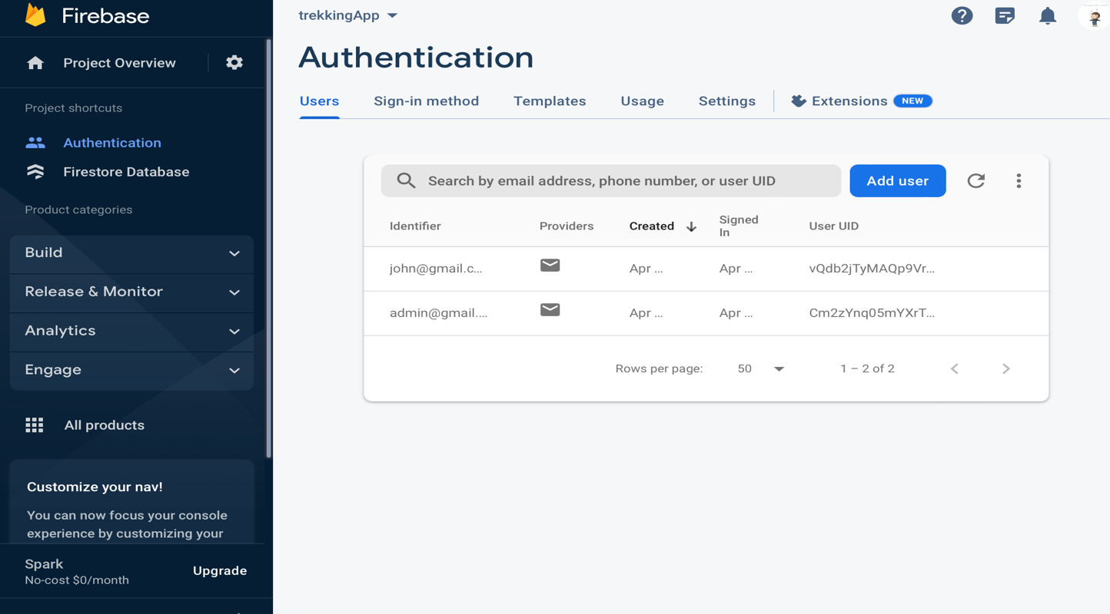

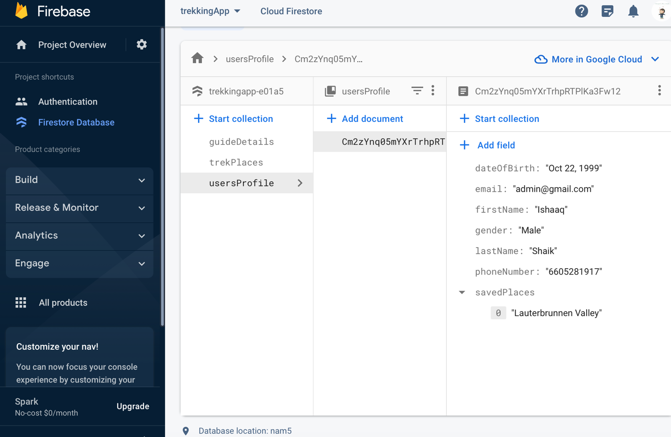

**ARCHITECTURE:**

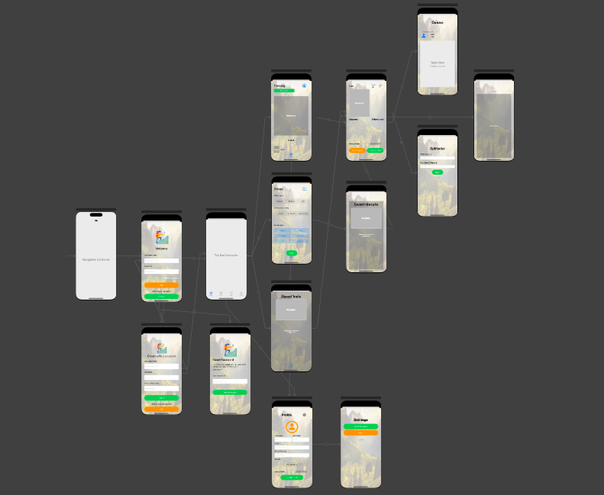

**WORKING VISUALISATION:**

**#Launch Screen:**

This is the launch screen that comes up when the application is started, it basically has a logo.

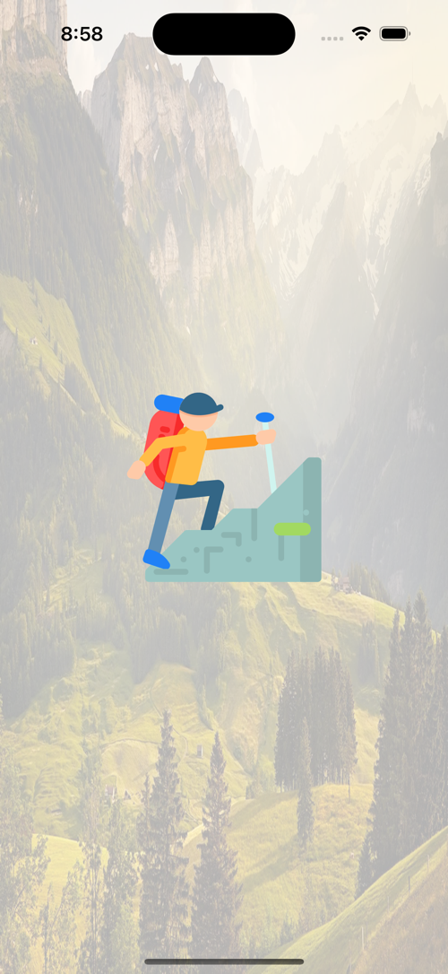

**#Forgot Password Screen:**

This the Reset password screen where user can reset their password if they forgot it. We can send a link to the registered email to reset their password here.

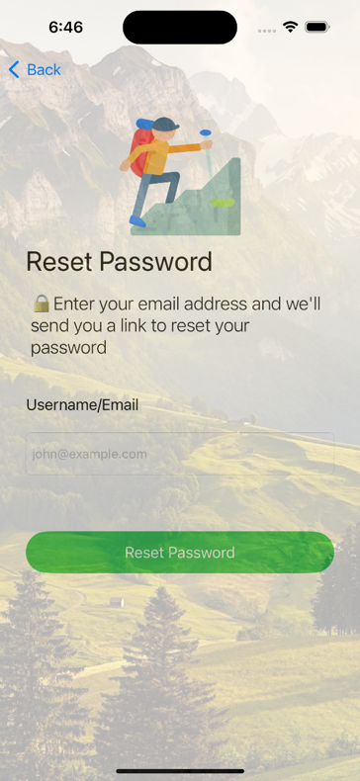 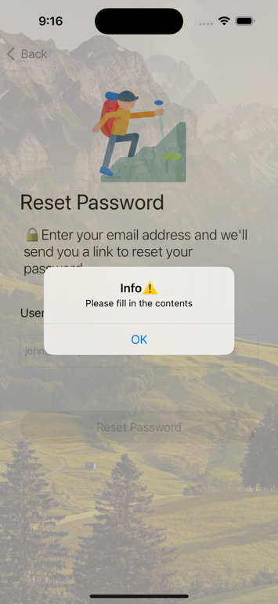 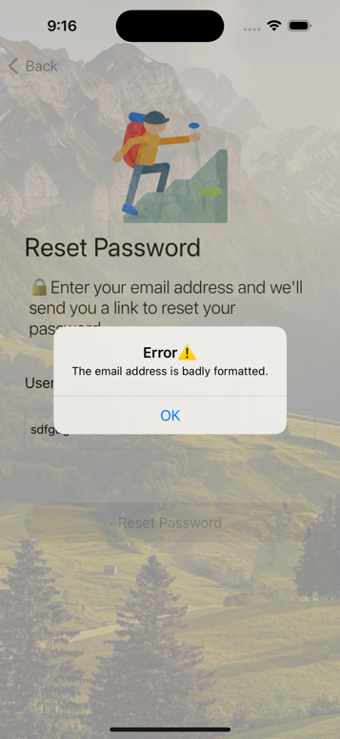

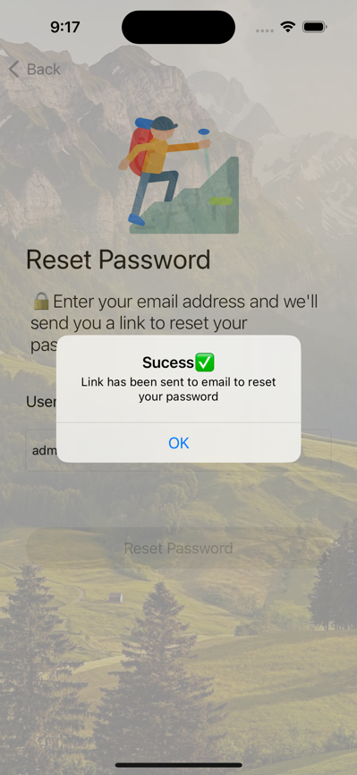

**#Registration Screen:**

This the registration screen where a new user can create an account by giving some basic information like username/email and password. If the user is an already registered user they can simply use the login button to redirect to login screen and login.

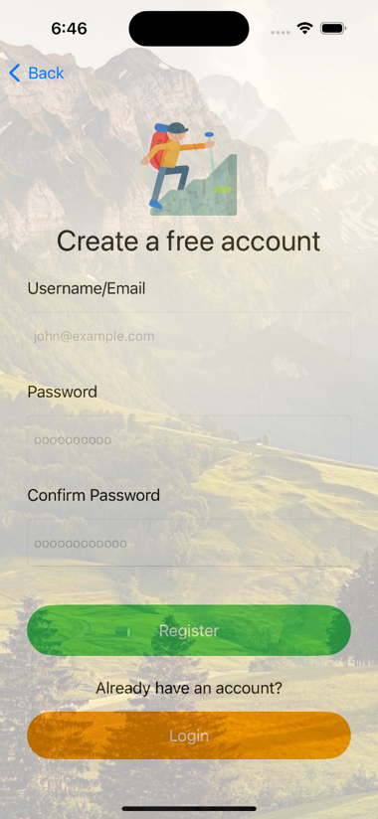 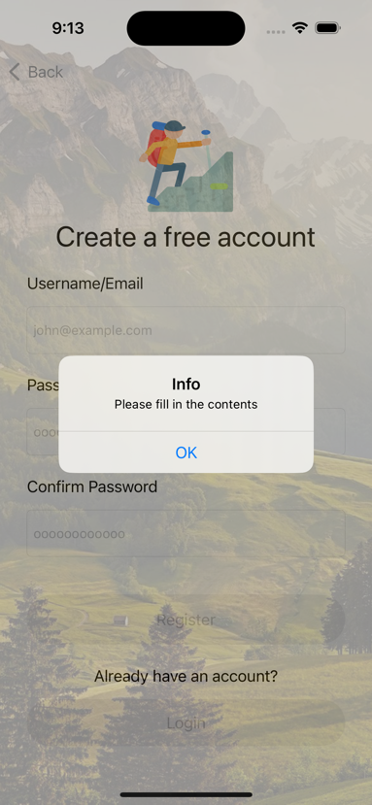 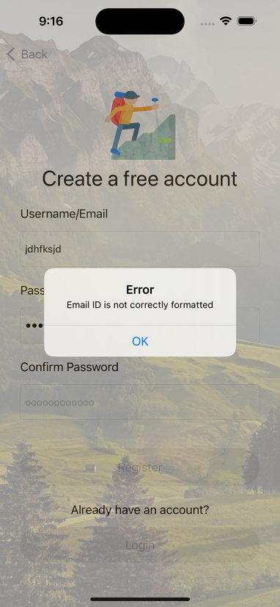

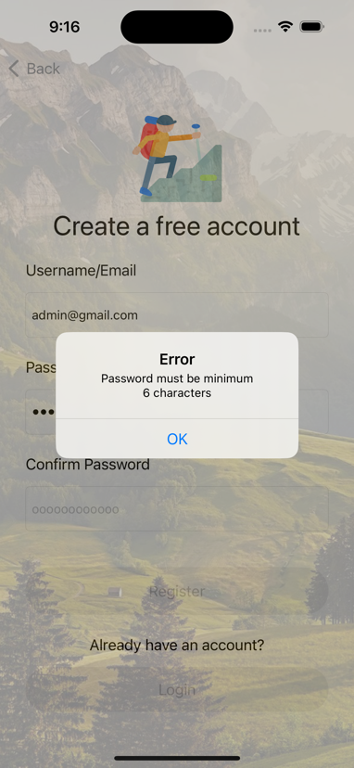 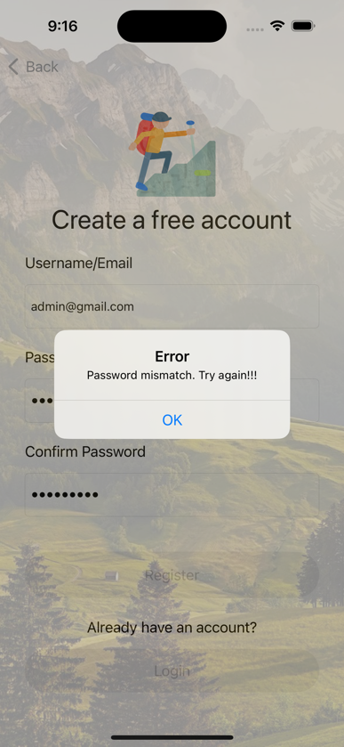

**#Login:**

Login screen welcomes the user to login with their credentials and button to reset users’ password if they forgot it and a button to register if the user is new to application.

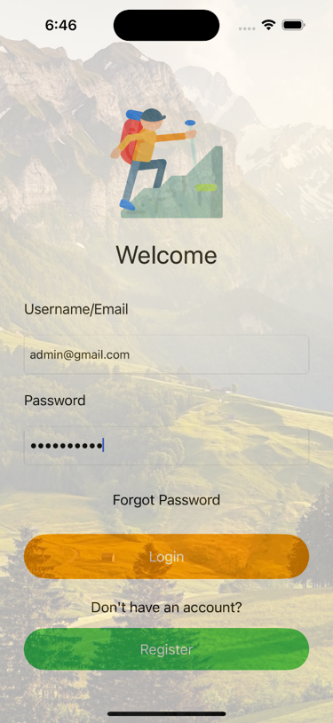 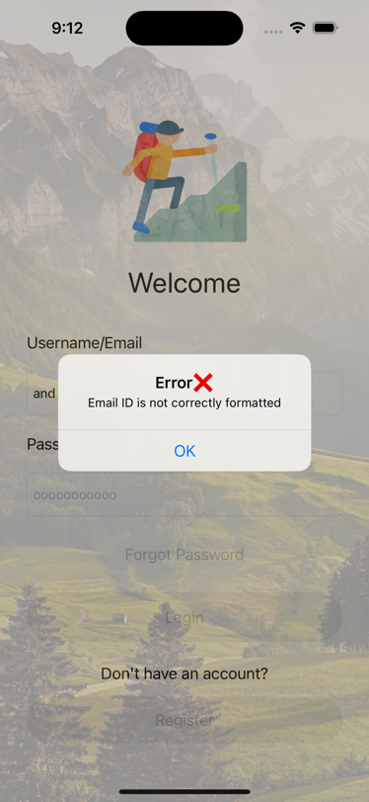 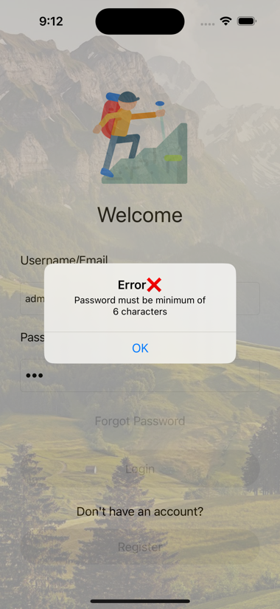

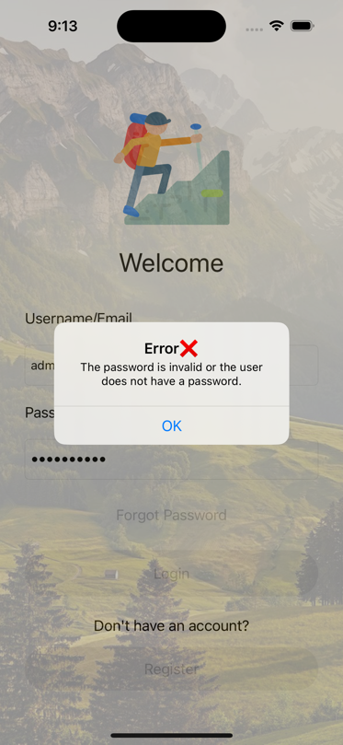

**#Home Screen:**

Once user logs in, they will land in to home screen where they can see some famous trekking places in slide show, and it will have the navigation tab to other screens in the bottom of the screen.

Tapping on a particular trek place, leads to next screen where you can view the complete details of the place.

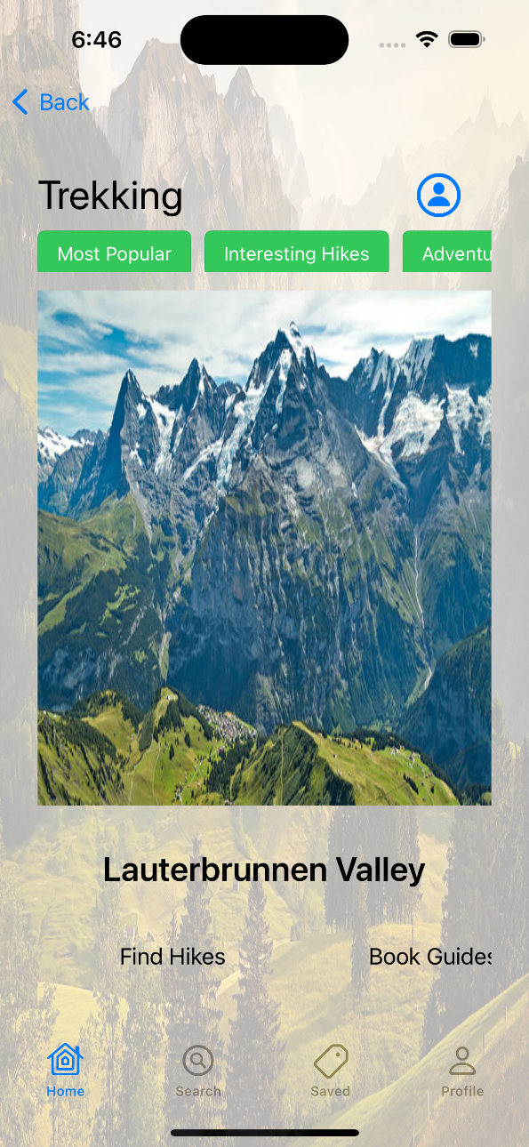

**#Trekking place Screen:**

When a user selects any trekking place they are redirected to the trekking details page where we show multiple images of the place, and details like total trail distance, effort level and a brief description of the place.

On Tapping on the image of the place, the trek place is added the user’s saved collection.

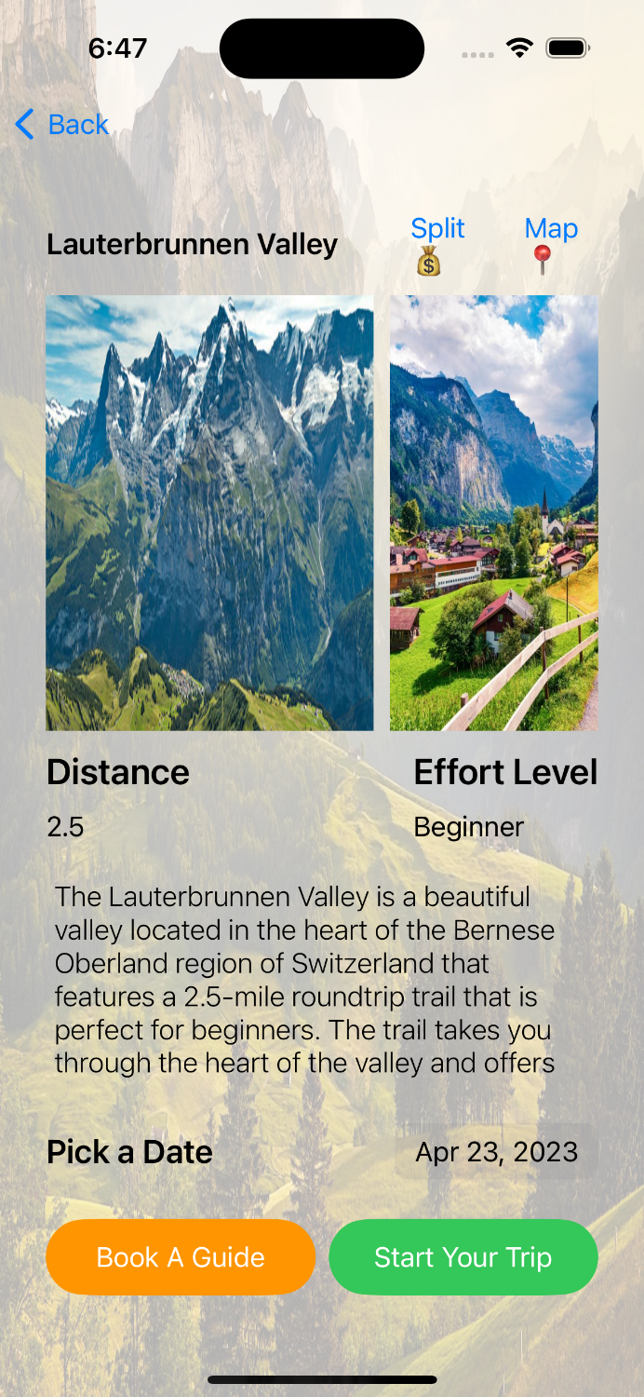 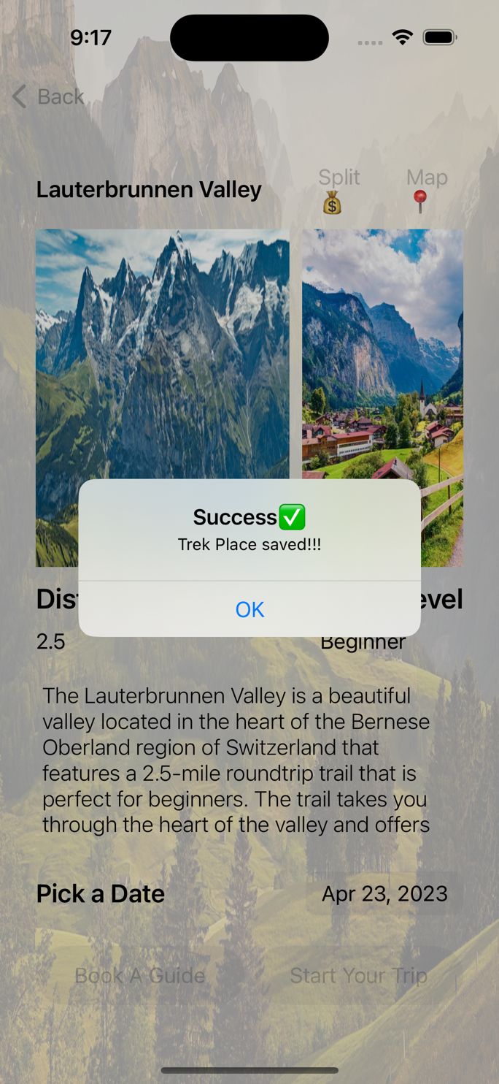

User can pick a date from calendar to attend trekking.

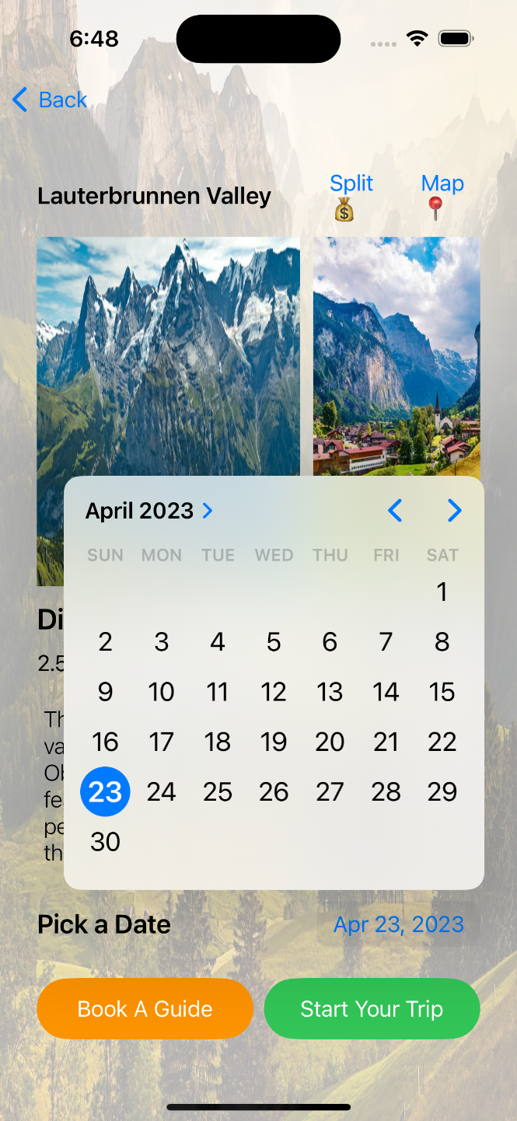

User can also book a guide if they want to, to explore and know about the in and around places of the trekking trail by clicking on Book A Guide button which redirects to this page.

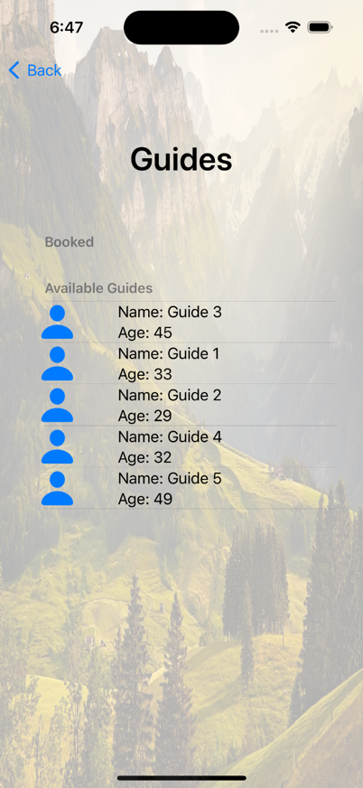 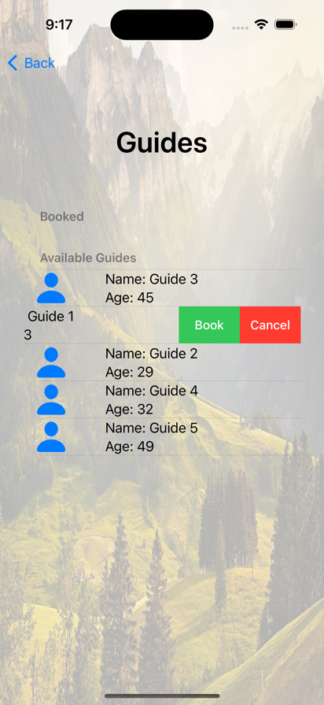 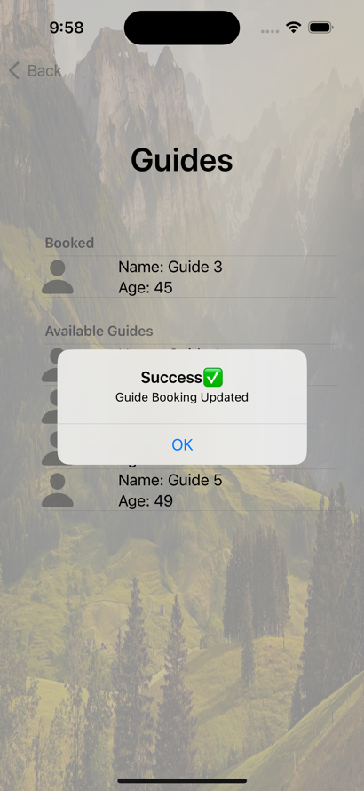

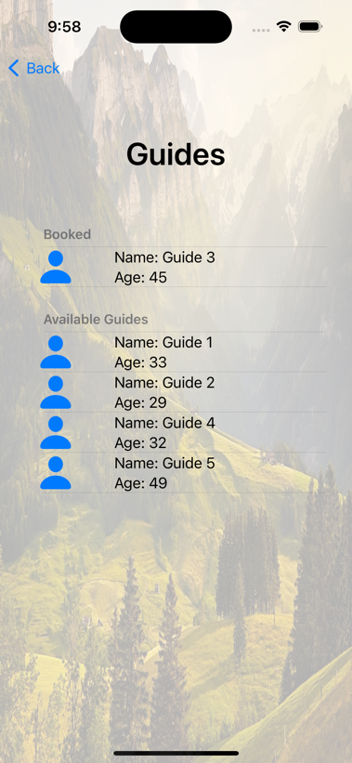

User can also create a calendar even directly from the application by clicking on Start your trip button. We used “EventKit” to add the events to your calendar. The notes added consist of the trek place details like name, distance and its description.

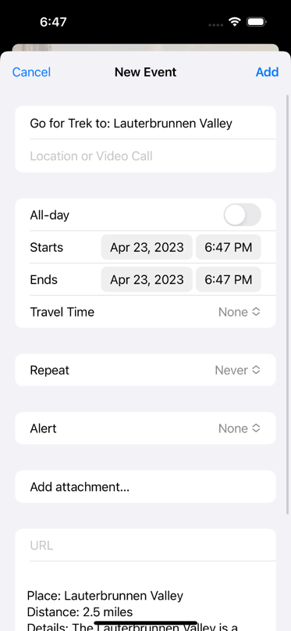

Calendar app

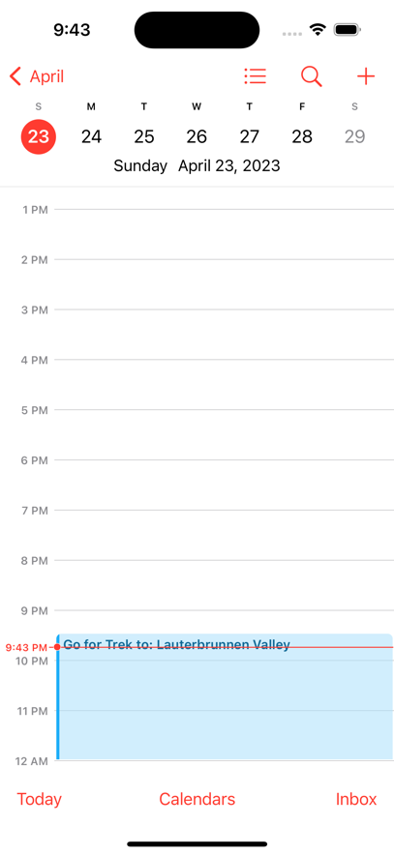 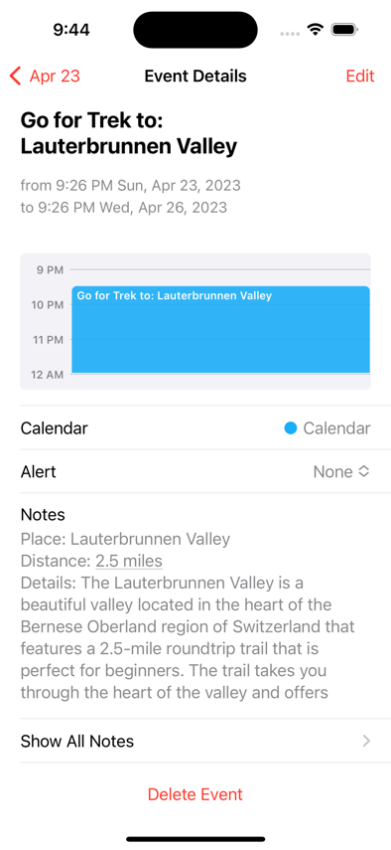

Users can also view the map view of the trekking trail using maps button beside the location title. Clicking on the close button, closes the Map screen.

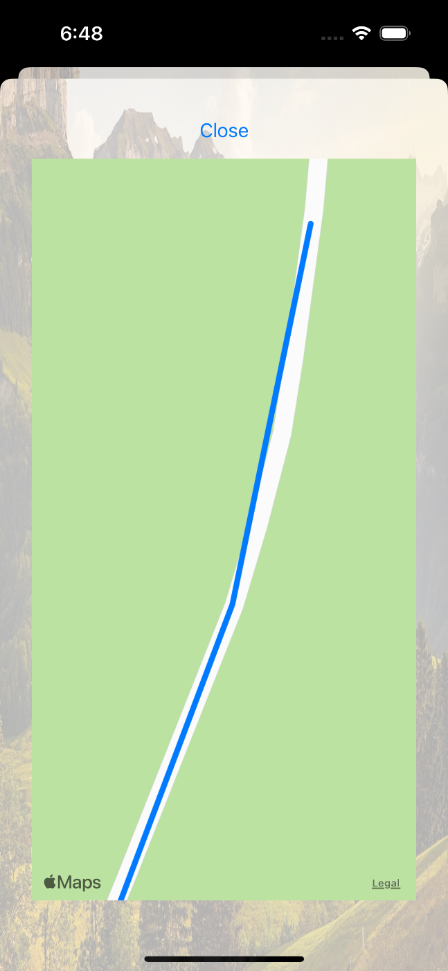

Users can also split the expenses, if they are attending the trip as a group by simply using the split button beside trekking place title. This is just a very basic sample implementation of just dividing the total expense among the total number of people.

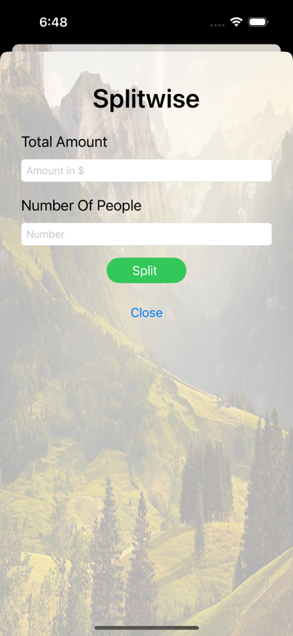 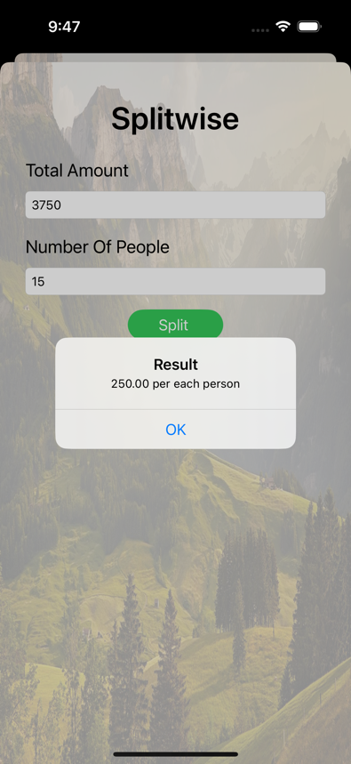 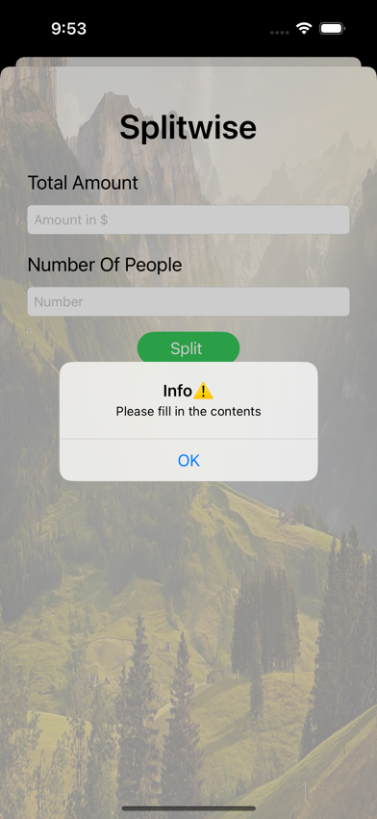

**#Search Screen:**

Here user can search for various available trekking places around the world with the provided filters.

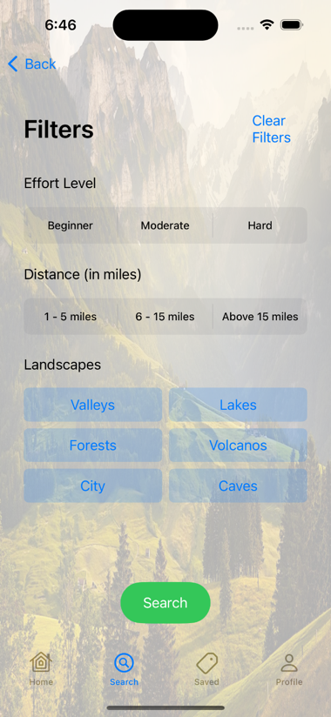 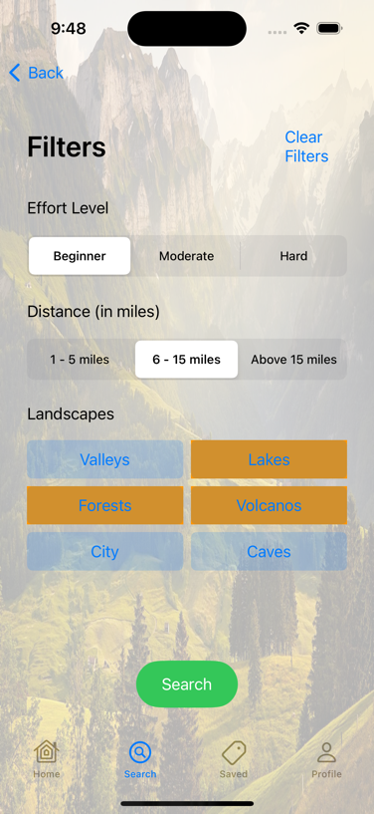 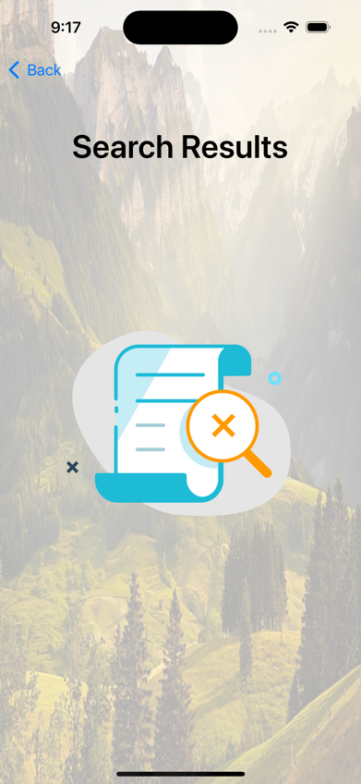

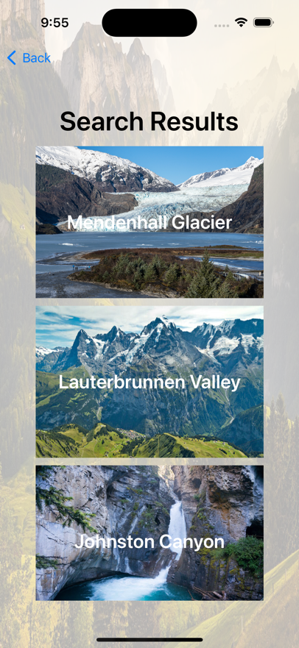

**#Saved trails Screen:**

User can save their favorite trekking places and those places will be shown here. When you tap on the trek place, it leads to the details screen

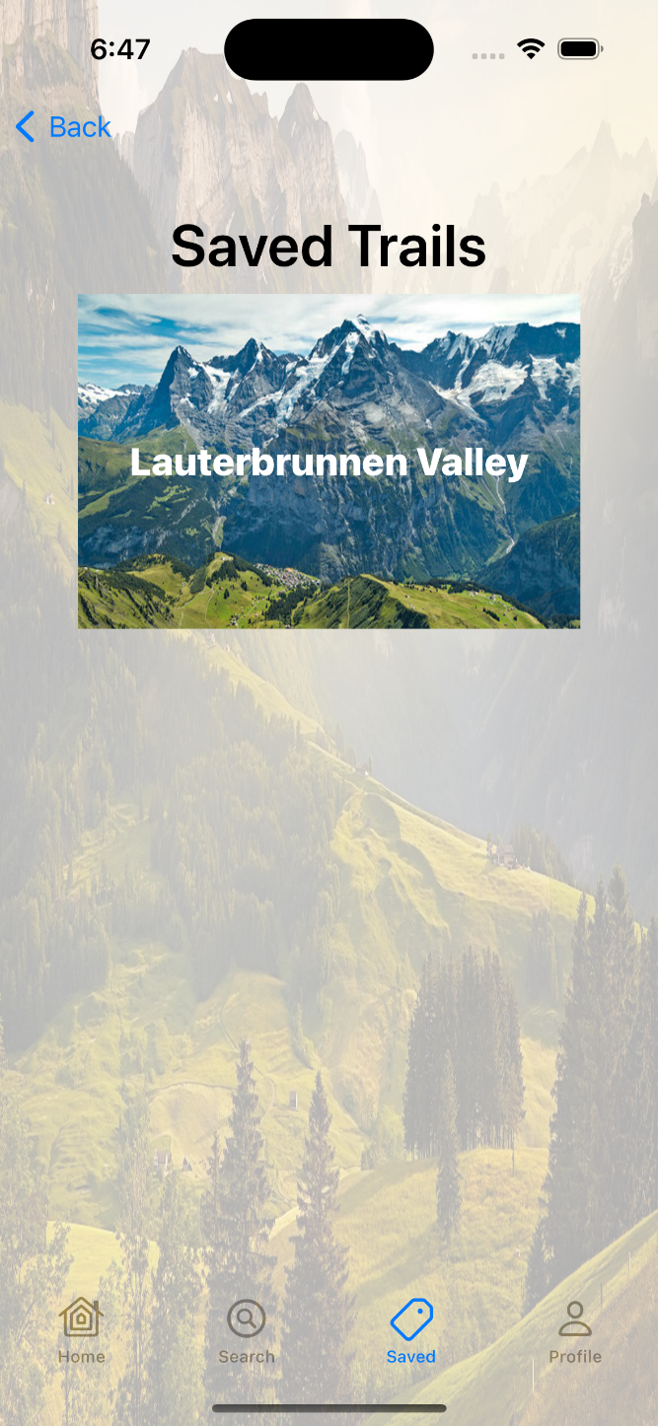

**#Profile Screen:**

This is the profile screen where a user can find their account details like first name, last name, gender, email address, phone number and date of birth.

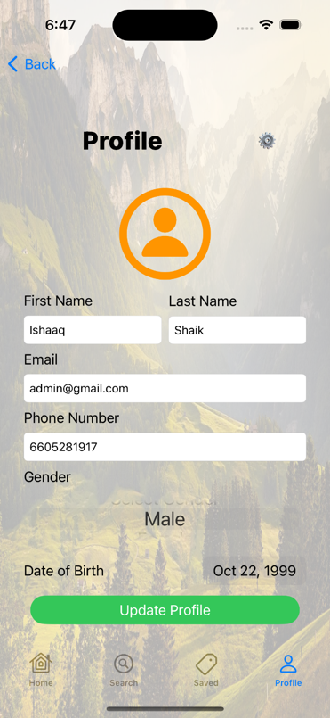 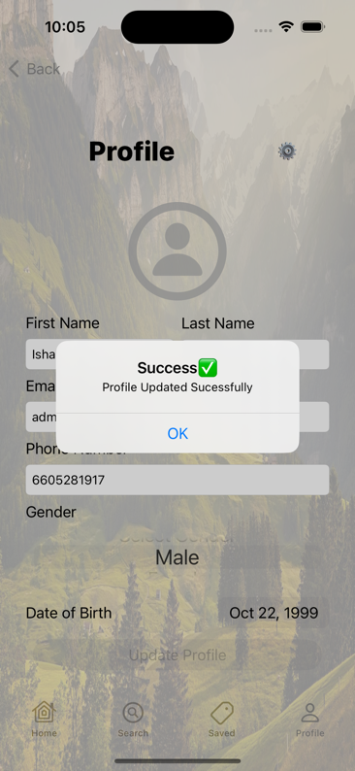 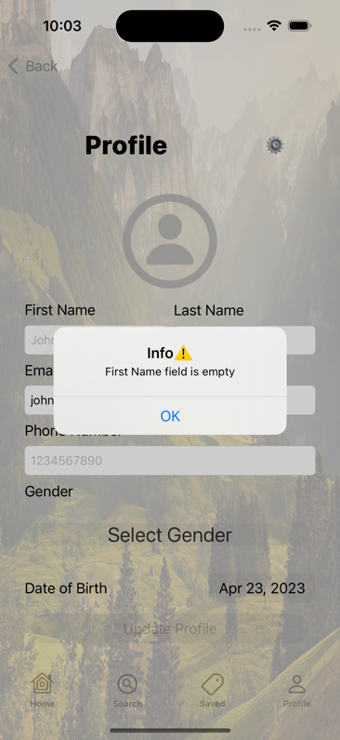

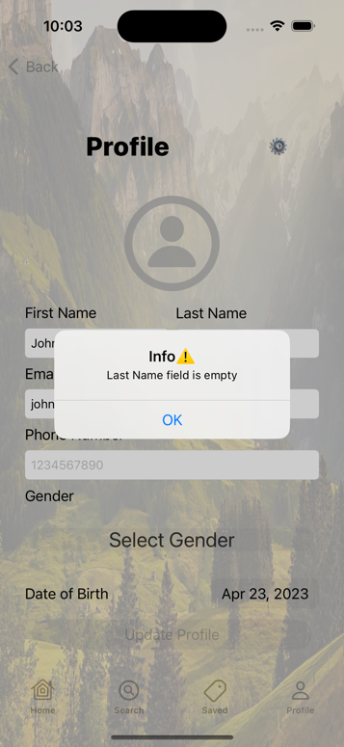 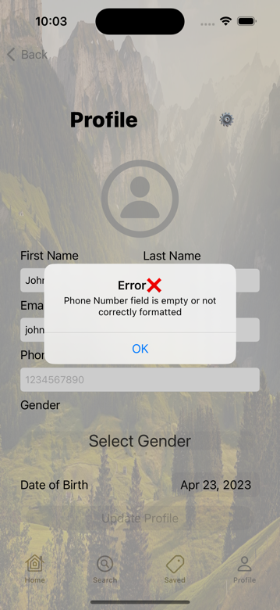 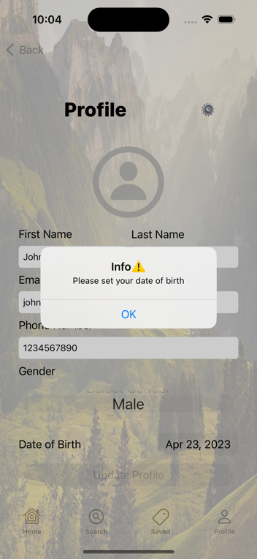

When user clicks on settings button from profile page we show options like reset password and logout functionalities.

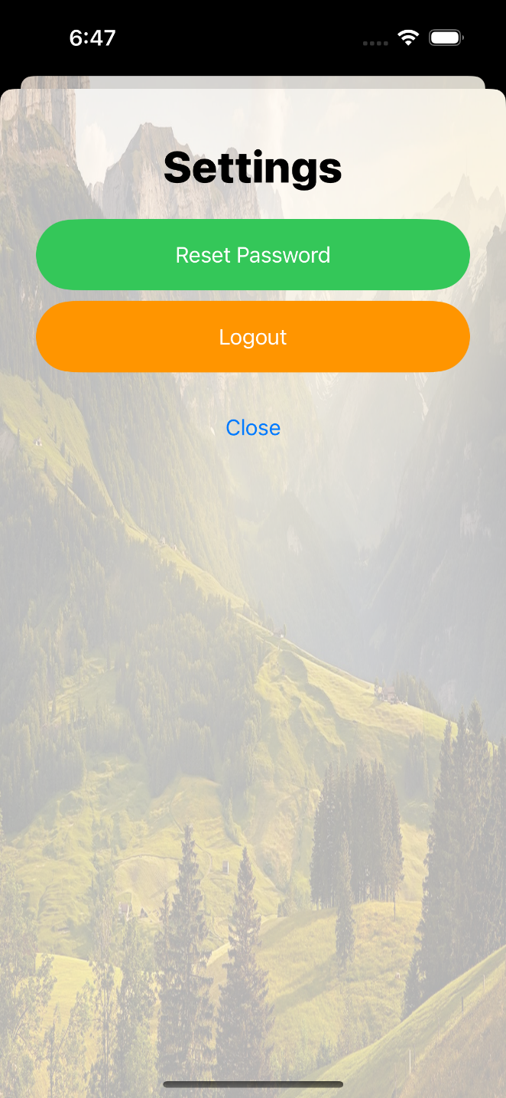

**CONCLUSION:**

In the future, we aim to enhance the user interface of the application to make it more intuitive and user-friendly for all devices. We also plan to improvise already existing features like split the cost of trek with troops, maps integrity etc. We also plan to add new features such as the GPS to live track the trekking. Furthermore, we will explore the possibility of integrating the app with social media platforms to enable users to share their trekking experiences with friends and to receive alerts about upcoming trekking events. Overall, we are committed to continuously improving the app to provide our users with the best possible trekking experience.